DNS Filtering

✅ What is DNS Filtering?
# Source: Chatgpt (GPT-5-Mini) at [1/18/2026]
DNS Filtering is a security technique that blocks or allows access to specific websites based on their domain names (DNS).
It works by intercepting DNS queries (like facebook.com) and deciding whether to allow or deny them before the site even loads.

🧠 Simple Explanation:
# Source: Chatgpt (GPT-5-Mini) at [1/18/2026]
When you try to visit a website, your device asks:
"What is the IP address of this domain?"
DNS filtering checks that domain name and says:
- ✅ If it's safe → returns the IP address
- ❌ If it's blocked → denies the request or redirects

🔒 What It Can Be Used For:
# Source: Chatgpt (GPT-5-Mini) at [1/18/2026]
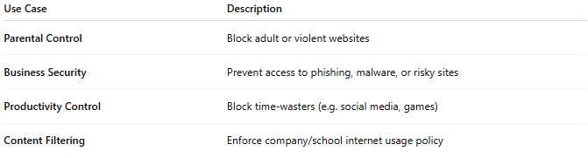
Use Case | Description
Parental Control | Block adult or violent websites
Business Security | Prevent access to phishing, malware, or risky sites
Productivity Control | Block time-wasters (e.g. social media, games)
Content Filtering | Enforce company/school internet usage policy

⚙️ How DNS Filtering Works:
# Source: Chatgpt (GPT-5-Mini) at [1/18/2026]
- You type badwebsite.com in the browser
- Your device sends a DNS request
- The DNS filtering server checks its blocklist/allowlist
- If blocked → request fails or is redirected to a warning page
- If allowed → DNS resolves and page loads

📦 Examples of DNS Filtering Services:
# Source: Chatgpt (GPT-5-Mini) at [1/18/2026]
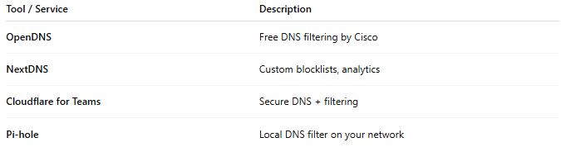
Tool / Service | Description
OpenDNS | Free DNS filtering by Cisco
NextDNS | Custom blocklists, analytics
Cloudflare for Teams | Secure DNS + filtering
Pi-hole | Local DNS filter on your network

🛡️ Pros
# Source: Chatgpt (GPT-5-Mini) at [1/18/2026]
- ✅ Stops threats before connection is made
- ✅ Easy to apply network-wide
- ✅ Lightweight (just DNS level, no full proxy needed)
- ✅ Great for schools, businesses, parents

⚠️ Cons
# Source: Chatgpt (GPT-5-Mini) at [1/18/2026]
- ❌ Can be bypassed (e.g. by changing DNS settings or using DoH)
- ❌ Might block legitimate sites if list isn't updated

✅ Summary
# Source: Chatgpt (GPT-5-Mini) at [1/18/2026]
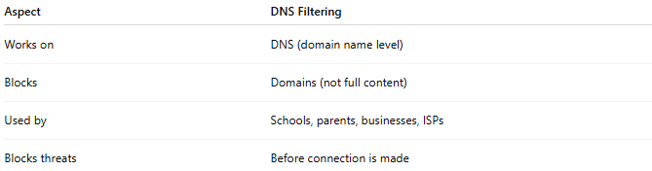

Aspect | DNS Filtering
Works on | DNS (domain name level)
Blocks | Domains (not full content)
Used by | Schools, parents, businesses, ISPs
Blocks threats | Before connection is made

Would you like help setting up DNS filtering using OpenDNS, Cloudflare, or Pi-hole?

